
AI agents that do the busywork inside the tools you already use.
Business Plan
Model, market, pricing, forecast and plan for the first 12 months
Version 1.0 · October 30, 2026 · plaiceholder.io

Executive summary
PlAIceholder sells pre-built AI agents to US companies with 10 to 200 employees. The base-case plan reaches 26 clients, 30 agents and about $131,000 in revenue in the first 12 months, run by one founder plus a part-time contract developer.
- What we sell: an agent that takes over one slow, repetitive judgment task, such as researching prospects, flagging renewals at risk, or checking invoices before payment. It works inside tools the client already pays for (HubSpot, Salesforce, Apollo, Zendesk, Slack, QuickBooks) and on the AI platform they already use (Claude, ChatGPT, Perplexity, Grok, Gemini or Copilot).
- How it's delivered: a two-week launch with a 20-record pilot and a measured before-and-after result. The client receives the agent and runs it in their own accounts, under a license for internal use.
- How we earn: a one-time launch package ($2,250 / $4,850 / $8,250bytier,includingthefirst3monthsofcare),thenacareplan($250 / $450 / $750 a month). The care plan keeps the agent working as tools and AI models change.
- Why it works: 76% of small businesses say they use AI, but only 14% have fully integrated it into core operations. Nearly half cite a lack of technical expertise (Goldman Sachs 10,000 Small Businesses, 2026). We close that gap with templates rather than custom builds, so we can price well below agencies.
- The edge: one builder turns any catalog template into a tested, versioned delivery for a specific client, tools and AI platform with a single command. That keeps the cost of each new client low, and keeps every client's agent separate for maintenance.
12-month target (base case) | Value
Clients | 26
Agents delivered | 30
Revenue | about $131,000
Monthly care revenue at month 12 | about $4,500 (11 paying plans; another 14 in their included months)
Operating profit before owner pay and taxes | about $115,000

Company and offer
PlAIceholder (plaiceholder.io) is a one-founder AI agent studio operating as [legal entity name]. It sells outcomes, not hours: one agent, one painful task, live in about two weeks.
Customer | US companies with 10 to 200 employees. They can afford to outsource a project but not to hire a full-time AI engineer
Buyers | Owners, sales leaders, heads of operations, customer success leads, controllers
Product | 13 catalog agents across sales, customer success, back office and marketing, plus custom agents built as new templates
Delivery | Launch package: discovery interview, tuning, 20-record pilot, measured result, training, 3 months of care
Recurring | Monthly care plan: monitoring, fixes when tools or AI models change, tuning hours, monthly results report, fix guarantee
Where it runs | In the client's own accounts, with their keys, on the AI platform they choose
The tagline: "AI agents that do the busywork inside the tools you already use."

Problem and market
Small businesses already use AI, but mostly as a chat tool. Few have it running inside the work itself, and the main blockers are expertise and trust. That gap is our market.
- The US has 36.2 million small businesses, which account for almost 46% of private-sector employment (SBA Office of Advocacy, June 2025). Our target is the much smaller slice with 10 to 200 employees and a CRM, help desk or accounting system worth connecting.
- In a January 2026 survey of 1,256 small business owners, 76% use AI and 93% of users report a positive impact, but only 14% have fully integrated AI into core operations (Goldman Sachs 10,000 Small Businesses).
- The same users name the blockers: data privacy and security (50%), lack of technical expertise (49%) and difficulty choosing the right tools (48%). 73% say they'd benefit from more help implementing AI.
- The Federal Reserve's Small Business Credit Survey finds nearly 40% of firms using or planning to use AI. Firms cite limited time for staff training and knowledge gaps about implementation as barriers (Federal Reserve Bank of San Francisco, July 2026).
How we answer each blocker
Blocker | Our answer
Privacy and security | Agent runs in their accounts with their keys; we delete our copies at handover; published data policy
No technical expertise | We do the build, tuning, pilot and maintenance; they answer questions in a 1-hour interview
Choosing tools | We use the CRM and AI platform they already have, with no new subscription required
Trust in AI output | Every finding links to its source; rules come first; nothing is sent, paid or written without a yes
Competition. Hiring an automation engineer costs $90,000 to $140,000 a year in salary (Evolv). SMB AI agencies charge $1,500 to $7,500 per workflow plus $500 to $1,500 a month (Taskip). GTM agencies run $2,500 to $10,000 or more a month (Salesforge). Built-in CRM AI features are generic and tied to higher subscription tiers. We sit at the low end of agency pricing, with pre-built templates, a measured pilot and platform choice.

How the model works when we hand the agent over
We give clients the agent itself: plain files they run in their own accounts. We can't technically lock a copy of plain files, and we don't try to. The business stands on three things instead: a license, a service clients need, and being the fastest people to fix their agent.
1. The license: legal protection, not a kill switch. Our code and templates are protected by copyright. The Master Services Agreement grants an internal-use license only once the launch package is paid in full: no resale, no sharing, no competing use. If the launch package isn't paid, no license exists and the client must stop using the agent. Enforcement is contractual, like any software license, and we never remotely disable or delete anything in a client's systems. That would contradict our "you own it" promise and create legal risk.
2. The care plan: a service clients actually need. What clients pay for each month is people and process, not access:
- Agents wear out without anyone touching them. HubSpot and Salesforce retire API versions, Apollo renames endpoints, and AI models get retired and replaced. An unmaintained agent typically breaks or degrades within months.
- Quiet failure is the bigger risk. A crash is obvious. A news source drying up, scores drifting or emails bouncing is not, and reps stop trusting the agent without knowing why. Monitoring catches it.
- The business changes. New products, new target markets and new reps make October's settings stale by spring. Included tuning hours keep the agent current.
- Proof every month. The monthly results report shows what the agent did and what it cost per record, so renewing the plan is an easy call.
- A fix guarantee. If a tool change breaks the agent, we fix it within 5 business days or that month is free.
3. Being the easiest path. We hold each client's settings history, their pinned copy of the template, every versioned delivery and a test setup that imitates their tools. We can fix their agent in hours where anyone else would need days to understand it.
Designed so the plan sticks
Mechanism | Effect
First 3 months of care included in the launch package | Clients decide to keep paying after seeing results, not before
Month to month after month 3, 30 days' notice | Low commitment, easy yes
Reactivation fee ($500 / $750 / $1,000) if a lapsed agent needs reviving | Staying on the plan is cheaper than leaving and coming back
$125/hour without a plan | Makes the plan's value plain
Founding clients commit to 6 months | Early recurring revenue while case studies are built
When a client stops paying. An unpaid care plan pauses our service after 15 days and ends after 30. The agent keeps running in their systems, and we remove our access and delete their data. An unpaid launch package means no license: written notice, then normal collections. The full procedure is in SOP-07.

Catalog, delivery modes and AI platform portability
Three agents are built, tested and demoable today. Ten more are specified and build on the same core in one to two weeks each. Every agent ships in two modes and on six AI platforms.
Area | Built | Specified
Sales | Signal Prospector (Advanced) | Inbound Lead Researcher, CRM Hygiene, Deal Follow-up Drafter, Meeting Prep Briefs
Customer success | Renewal Risk Radar (Standard) | Support Ticket Triage, Customer Onboarding Tracker
Back office | Invoice Checker (Standard) | Resume Screener, Weekly KPI Writer
Marketing | none yet | Competitor Watch, RFP and Questionnaire Drafter
Two delivery modes, same tuned settings
- Chat mode: a portable AGENT.md plus a ready-to-paste instruction file for the client's AI tool (Claude Project or skill, ChatGPT custom GPT, Perplexity Space, Grok, Gemini Gem, Copilot Studio agent). A person gives it data and reads the results. There's nothing to install.
- Automated mode: the runtime runs on a schedule, reads from and writes back to their CRM, help desk or accounting exports, and posts to Slack, using their AI platform's API key.
AI platform portability. Clients don't need a new AI subscription. We build with Claude, but each agent's spec is plain markdown in fixed sections (role, inputs, procedure, rules, scoring, output format, when to stop). Any capable model can follow it. The automated runtime supports Claude (with half-price batch processing), ChatGPT, Perplexity and Grok, plus Gemini for agents that don't need web search. The builder blocks combinations that can't work, such as a research agent on a platform without API web search. The procedure is in SOP-03.

Pricing and unit economics
Prices sit at the low end of SMB agency rates, while still paying the founder about $150 to $175 an hour at full price. The care plan pays a similar hourly rate once the included months end.
 | Starter | Standard | Advanced
Launch package (setup + 3 months of care) | $2,250 | $4,850 | $8,250
Founding price (first 5 clients, 6-month commitment) | $1,750 | $3,500 | $5,500
Care plan from month 4 | $250/mo | $450/mo | $750/mo
Founder hours to set up (estimate) | ~10 | ~20 | ~35
Founder hours per month of care (estimate) | ~1.5 | ~3 | ~4.5
Effective setup rate, full price | $150/hr | $175/hr | $171/hr
Effective care rate | ~$167/hr | ~$150/hr | ~$167/hr
Other terms:
- A second agent at the same company gets 25% off setup and care.
- Annual care prepay costs 10 months.
- Out-of-scope work is $125/hour.
- Custom agents cost the tier price plus $1,000 to $3,000 for the new template.
Client-paid usage goes directly to the AI and data providers: about $0.04 to $0.06 per company researched (Signal Prospector), $0.02 per account (Renewal Risk Radar) and $0.01 per reviewed exception (Invoice Checker). These are kit estimates; the pilot measures real costs.
Value to the client (example). An agent that saves one person 10 hours a week at $45/hour is worth about $1,950 a month. A Standard launch package pays back in about 2.5 months, and the $450 care plan costs less than a quarter of the monthly savings.
Watch the founding discount. Founding prices work out to roughly $95 to $105 an hour. That's acceptable for 5 case studies but no longer.

Go-to-market plan
We sell founder-led, through warm networks and proof, with one rule: lead with a live demo of a working agent on sample data, never with slides.
- Months 1 to 3: founding clients. Finish Praxis Escrow and publish the measured result. Sign 4 more founding clients from the founder's network, referrals and local business groups. The goal is 3 case studies with real numbers.
- Months 4 to 6: repeatable outreach. Each week, send 25 targeted emails or LinkedIn messages to companies showing the same signals our Signal Prospector finds. Use our own agent for our own prospecting. Add 2 partner channels, such as a HubSpot partner agency or a fractional COO/CFO network, paying a 10% referral fee on the launch package.
- Months 7 to 12: content and referrals. Publish one short teardown a month ("How a 40-person logistics company stopped double-paying invoices"), with client permission. Run a referral offer: one month of care free for each signed referral. Go deeper in the 2 industries where the early case studies land.
Funnel targets (base case, months 4 to 12): 100 touches a month → 8 calls → 4 proposals → 2 to 3 signed. That's a 3% touch-to-client rate, which we'll track and correct monthly.
Offer ladder: free 30-minute call with demo → launch package (one agent) → care plan → second agent at 25% off → custom agent. Most growth comes from second agents and referrals inside existing clients, since connections and trust are already in place.
The full scripts, objection handling and templates are in the PlAIceholder Sales Playbook.

Operations: the builder, client isolation, SOPs and tools
One builder, not one per agent type, turns any template into a tested, versioned delivery. The specialization lives in the templates and the process lives in the builder, so a process fix improves every agent at once.
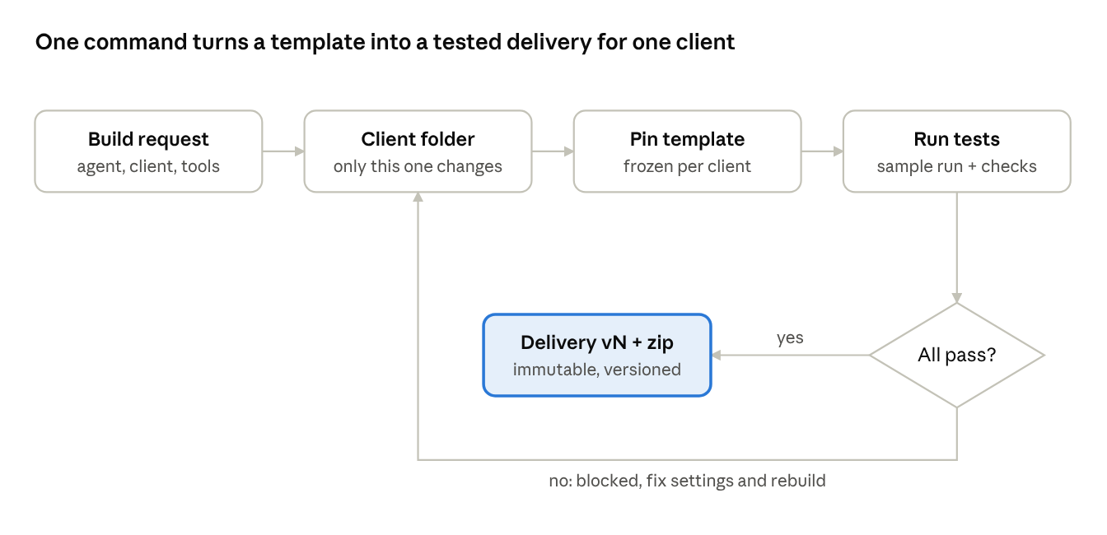
A build request names the agent, the client, their tools and their AI platform. Failed tests block delivery; passing builds become a new immutable version.
Keeping clients separate for maintenance
- One folder per client holds its tools, AI platform, care-plan status, delivery history, tuned settings and its own pinned copy of the template. Every command names one client and touches only that client's folders.
- Pinned templates. Improving a shared template never changes a delivered client. Upgrades are per client and opt-in (kit.py upgrade), with a backup.
- Immutable versions. Every change is a new version with a changelog note and a diff (kit.py diff). Rollback means resending the previous zip.
- Tests on every build, including a scan that refuses to deliver if any key value appears in the files.
Standard procedures (in docs/sop/): 01 Client onboarding · 02 Building an agent · 03 AI platform portability · 04 Testing and QA · 05 Delivery and handover · 06 Maintenance and changes · 07 Offboarding.
Tools and costs (estimates):
- Claude for building
- AI subscriptions and test credits: about $250/month
- Software (site, email, password manager, storage): about $80/month
- Insurance (errors and omissions, cyber): about $150/month
- Bookkeeping: about $100/month
- One-time attorney review of the contract templates: about $1,500
Trial accounts (HubSpot developer, Salesforce Developer Edition, Apollo, Zendesk) are free or low cost.

12-month financial forecast
In the base case, PlAIceholder is cash-positive from month 1. It brings in about $131,000 in year one, leaving about $115,000 before owner pay and taxes. Care plans build a recurring base of about $4,500 a month by month 12.
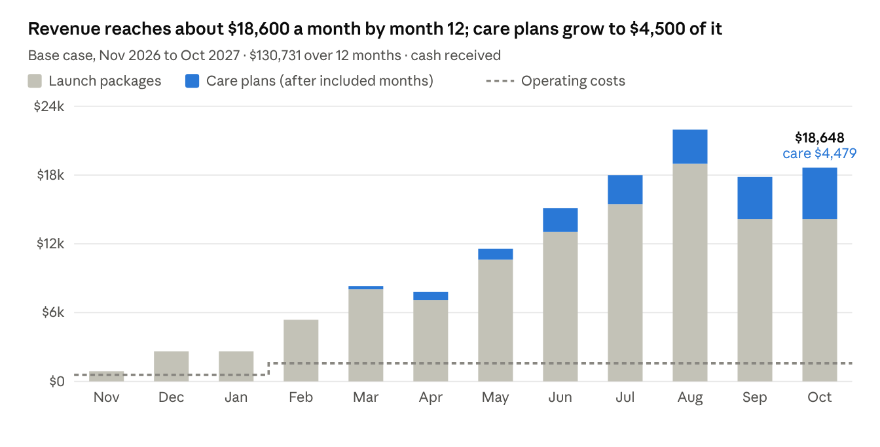
Launch-package cash dips in September and October because the funnel holds at 3 to 4 new agents a month. Growth after that has to come from more care plans, second agents and the referral channel.
Assumptions:
- New clients: 1 a month in months 1 to 3, 2 in months 4 to 7, and 3 in months 8 to 12. The first 5 are founding clients at founding prices.
- Tier mix: 40% Starter, 40% Standard, 20% Advanced.
- Second agents: 30% of clients buy one (Standard, 25% off) 4 months after their first.
- Care plans: 80% keep paying after the included months, with 3% monthly churn after that. Founding clients commit to 6 months.
- Payment timing: launch packages are paid 50% in the start month and 50% the next month.
- Costs: about $580 a month, plus a $1,000 a month contract developer from month 4, plus $1,500 one-time for legal review.
Scenario | New clients (12 mo) | Revenue (12 mo) | Profit before owner pay | Care revenue at month 12 | Founder hours/month at peak
Conservative (about half the wins) | 15 | ~$72,000 | ~$56,000 | ~$2,550/mo | ~92
Base | 26 | ~$131,000 | ~$115,000 | ~$4,500/mo | ~136
Upside (1 to 5 wins/month) | 43 | ~$224,000 | ~$208,000 | ~$7,600/mo | ~242
These are planning numbers, not results. Replace each assumption with real data as clients close; the model is a simple script and can be rerun in minutes.

Team and capacity
The founder can deliver about 120 billable hours a month alongside selling. In the base case, delivery work passes that around month 9 (about 110 to 136 hours), so that's when the first part-time hire is needed. In the upside case it's needed by month 5.
Role | When | Why
Founder: sales, discovery, tuning, client relationships | Now | Clients buy the founder's judgment and attention
Contract developer, about 10 hours a month | Month 4 (budgeted at $1,000/month) | Hard live-debugging, new connectors, code review: the founder isn't a full-time developer
Part-time delivery specialist (builds, pilots, monthly care routine) | When delivery passes 110 hours a month for 2 months (base case around month 9) | The SOPs and one-command builder make delivery teachable
Bookkeeper | Month 1 | Clean books for taxes and any future lending
Hire trigger rule: once 70% of the founder's month goes to delivery for two months in a row, hire, or raise prices 15% for new clients. Track hours per client from day one.

Risks and mitigations
The biggest risk is a template that works on sample data and fails on a client's real account. Every connector and AI platform gets a live trial test before a client depends on it.
Risk | Likelihood | Mitigation
Connectors untested on live accounts | High at first | Trial accounts per connector before first use (SOP-04); 20-record pilots; contract developer on call
Clients drop the care plan after the included months | Medium | Monthly results report, fix guarantee, reactivation fee, annual prepay discount; forecast assumes 20% drop plus 3% monthly churn
A client copies or shares the agent | Low | Internal-use license in the MSA; the value is the service, not the files; templates keep improving and are pinned per client
Tools or AI models change their APIs | Certain, ongoing | Covered by the care plan; fixes ship through rebuilds; stub tests for every connector
A wrong AI answer reaches a customer | Medium | Rules first, source and evidence checks, human approval before any send, payment or write
Messy client data doubles the work | Medium | "Clean data assumed" in every SOW; cleanup billed hourly; the CRM Hygiene agent
Key or data exposure | Low | Data policy, hidden key entry, secrets scan on every delivery, deletion at handover, 72-hour incident notice
Founder capacity | High by month 9 | Hire trigger rule; one-command builder and SOPs make delivery teachable
AI regulation (for example automated hiring tools) | Medium for some agents | Human-in-the-loop by design; Resume Screener never auto-rejects; local rules checked before selling
Price pressure from built-in CRM AI features | Medium | Sell depth, tuning and measured results, not generic features; work across the tools and AI platforms the client already has

Milestones
The first gate is publishing the Praxis Escrow result. Everything after it sells on proof.
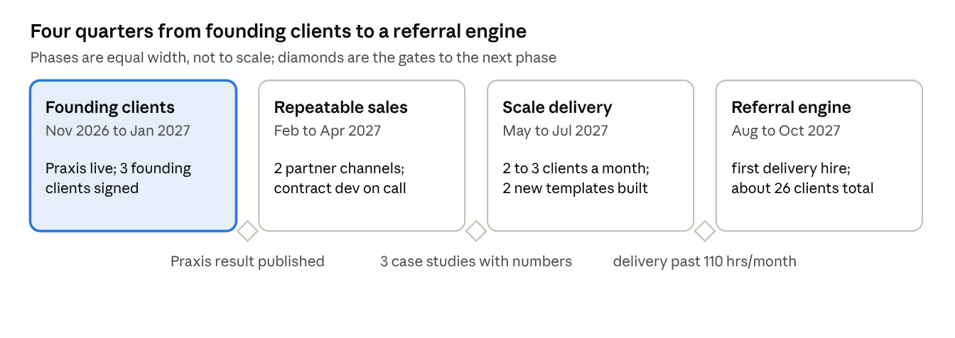
Each phase starts only when its gate is met. If a gate slips, the next phase waits, rather than spending ahead of proof.
Next 30 days
☐ Finish the Praxis live test and pilot; publish the measured result with permission
☐ Live-test every connector and AI platform on trial accounts (SOP-04)
☐ Attorney review of the MSA, SOW, care plan terms and data policy
☐ Update plaiceholder.io pricing to the launch-package model and add the care-plan FAQ
☐ Sign founding clients 2 and 3
☐ Get errors-and-omissions and cyber insurance quotes

Sources
- SBA Office of Advocacy: number of small businesses exceeds 36 million (June 2025)
- Goldman Sachs 10,000 Small Businesses: AI survey (January to February 2026)
- Federal Reserve Bank of San Francisco: AI adoption in small businesses (July 2026)
- Evolv AI Agents: AI automation agency pricing 2026
- Taskip: AI automation agency pricing 2026
- Salesforge: Clay and GTM agencies
- PlAIceholder website

